Finding available rooms at Canadian Western Bank

The desktop version of Outlook is an amazing tool representing some 20-30 years of iterative improvement. However, searching for available rooms is a trail-and-error process.
With the online version of Outlook that all CWB employees have access to, booking rooms immediately or in the future is very easy.
Additionally, any meetings booked using the online version of Outlook syncs to your desktop version as well.
Steps:
- Launch your Internet Explorer browser.
- Go to “https://www.office.com/”
- Click sign in.
- Enter your CWB email address, like firstname.lastname@cwbank.com [example: jogi.nijjar@cwbank.com];
- When you click next, single-sign on should work and you will not be required to supply your password.
  - If not, supply the password you log into your computer with.
- Once you are logged in, you should see this dashboard:

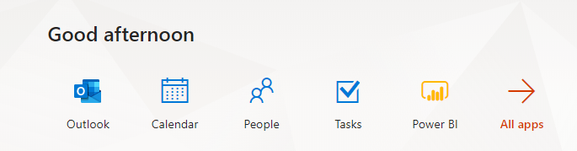
- Click the “Calendar” icon.
- You will be presented with a grid to enter in appointments.
- Click into the timeslot you are interested in (or double click to bring up a much richer appointment window)
- You will see a line called “Search for a room or location”
- Click into this line.
- You are now presented with all available rooms at this time slot.

